姓名：唐璐 | 专业：信息管理与信息系统 | 班级：20181171 | 学号：2018117135
科目： 安卓 |  | 实验日期：2021/6/22
实验题目：
【实验目的】

【实验环境及方式】
一、创建项目ListViewTest
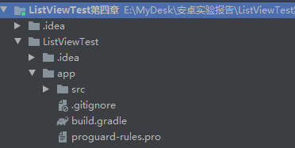
二、修改activity_main_xml文件的代码
<?xml version="1.0" encoding="utf-8"?>
<LinearLayout xmlns:android="http://schemas.android.com/apk/res/android"
android:orientation="vertical"
android:layout_width="match_parent"
android:layout_height="match_parent">
<ListView
android:id="@+id/list_view"
android:layout_width="match_parent"
android:layout_height="match_parent" >
</ListView>
</LinearLayout>

修改mainActivity文件的代码
private void initFruits() {
for (int i = 0; i < 2; i++) {
Fruit apple = new Fruit("Apple", R.drawable.apple_pic);
fruitList.add(apple);
Fruit banana = new Fruit("Banana", R.drawable.banana_pic);
fruitList.add(banana);
Fruit orange = new Fruit("Orange", R.drawable.orange_pic);
fruitList.add(orange);
Fruit watermelon = new Fruit("Watermelon", R.drawable.watermelon_pic);
fruitList.add(watermelon);
Fruit pear = new Fruit("Pear", R.drawable.pear_pic);
fruitList.add(pear);
Fruit grape = new Fruit("Grape", R.drawable.grape_pic);
fruitList.add(grape);
Fruit pineapple = new Fruit("Pineapple", R.drawable.pineapple_pic);
fruitList.add(pineapple);
Fruit strawberry = new Fruit("Strawberry", R.drawable.strawberry_pic);
fruitList.add(strawberry);
Fruit cherry = new Fruit("Cherry", R.drawable.cherry_pic);
fruitList.add(cherry);
Fruit mango = new Fruit("Mango", R.drawable.mango_pic);
fruitList.add(mango);
}
}

三、提升效率
@Override
public View getView(int position, View convertView, ViewGroup parent) {
Fruit fruit = getItem(position);
View view;
ViewHolder viewHolder;
if (convertView == null) {
view = LayoutInflater.from(getContext()).inflate(resourceId, parent, false);
viewHolder = new ViewHolder();
viewHolder.fruitImage = (ImageView) view.findViewById (R.id.fruit_image);
viewHolder.fruitName = (TextView) view.findViewById (R.id.fruit_name);
view.setTag(viewHolder);
} else {
view = convertView;
viewHolder = (ViewHolder) view.getTag();
}
viewHolder.fruitImage.setImageResource(fruit.getImageId());
viewHolder.fruitName.setText(fruit.getName());
return view;
}

四、设置点击事件
@Override
protected void onCreate(Bundle savedInstanceState) {
super.onCreate(savedInstanceState);
setContentView(R.layout.activity_main);
initFruits(); // 初始化水果数据
FruitAdapter adapter = new FruitAdapter(MainActivity.this, R.layout.fruit_item, fruitList);
ListView listView = (ListView) findViewById(R.id.list_view);
listView.setAdapter(adapter);
listView.setOnItemClickListener(new AdapterView.OnItemClickListener() {
@Override
public void onItemClick(AdapterView<?> parent, View view,
int position, long id) {
Fruit fruit = fruitList.get(position);
Toast.makeText(MainActivity.this, fruit.getName(), Toast.LENGTH_SHORT).show();
}
});
}

六、运行程序
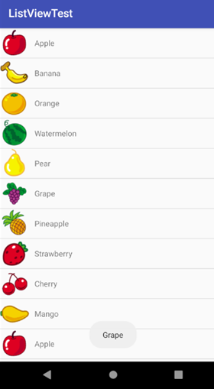

【教师评语和成绩】

成绩： 指导教师： 日期：

